-----*------*-----

TÀI LIỆU
HƯỚNG DẪN TÍCH HỢP MYCC ANDROID SDK

Hà Nội, 2021

Tích hợp module
- Click vào File -> New -> New Module -> Cửa sổ chọn Module hiển thị, chọn Import JAR/.AAR Packages.

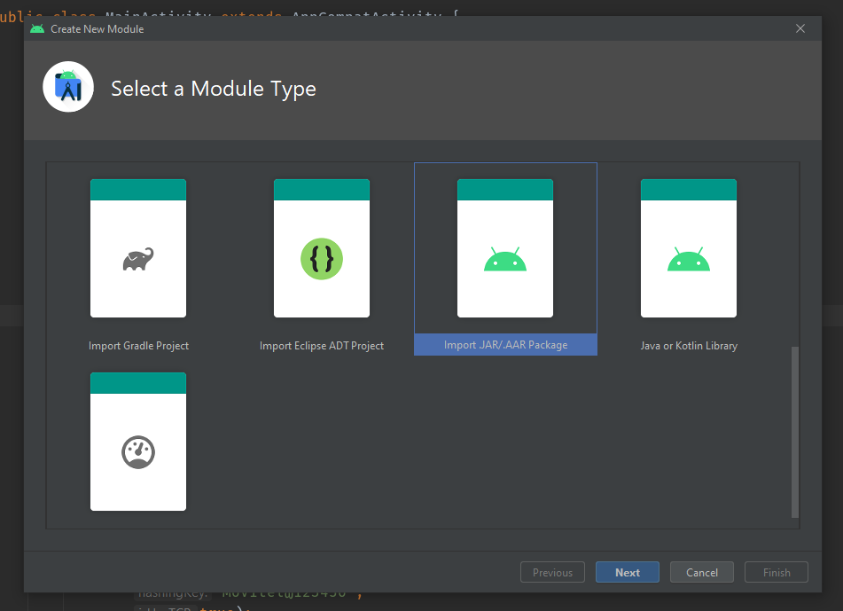
- Tìm đến thư mục chứa file IPCCSupportSDK.aar, chọn Import.
- Thêm các quyền và feature cần thiết trong Manifest.xml:

<uses-permission android:name="android.permission.RECORD_AUDIO"/>
<uses-permission android:name="android.permission.RECORD_VIDEO" />
<uses-permission android:name="android.permission.INTERNET" />
<uses-permission android:name="android.permission.READ_CONTACTS"/>
<uses-permission android:name="android.permission.READ_PHONE_STATE"/>
<uses-permission android:name="android.permission.CAMERA"/>
<uses-permission android:name="android.permission.ACCESS_FINE_LOCATION" />
<uses-permission android:name="android.permission.ACCESS_NETWORK_STATE" />
<uses-permission android:name="android.permission.ACCESS_COARSE_LOCATION" />
<uses-permission android:name="android.permission.USE_SIP" />
<uses-permission android:name="android.permission.MODIFY_AUDIO_SETTINGS" />
<uses-permission android:name="android.permission.PROCESS_OUTGOING_CALLS" />
<uses-permission android:name="android.permission.WAKE_LOCK" />
<uses-permission android:name="android.permission.VIBRATE" />
<uses-permission android:name="android.permission.ACCESS_WIFI_STATE" />
<uses-permission android:name="android.permission.READ_EXTERNAL_STORAGE"/>
<uses-feature android:name="android.hardware.camera2" />
<uses-feature android:name="android.hardware.camera2.autofocus" />

- Setup dependencies trong Build.gradle:
implementation fileTree(dir: 'libs', include: ['*.jar', '*.aar'])
implementation project(':IPCCSupportSDK')
implementation 'com.google.code.gson:gson:2.8.5'
implementation 'com.squareup.retrofit2:retrofit:2.5.0'
implementation 'com.squareup.okhttp3:logging-interceptor:3.9.0'
implementation 'com.squareup.retrofit2:converter-gson:2.5.0'
implementation 'com.makeramen:roundedimageview:2.3.0'
implementation 'com.nabinbhandari.android:permissions:3.8'

Khởi tạo SDK
- Tạo biến IPCCSupportSDK:

private IPCCSupportSDK ipccSupportSDK;

- Tạo cấu hình cho SDK:

LiveConfig config = new LiveConfig(
"baseURL",
"port",
"sipProxy",
"chatDomain",
"chatJsURL",
"callFlow",
"videoCallFlow",
"hasingKey",
Boolean isUsingTCP);

- Khởi tạo SDK:

ipccSupportSDK = IPCCSupportSDK.instance;
ipccSupportSDK.init(getSupportFragmentManager(), this);
ipccSupportSDK.setLiveConfig(config);

Sử dụng SDK
- Hiển thị màn hình Chat:

try {
ipccSupportSDK.showChatView(userName);
} catch (InitSDKExeption initSDKExeption) {
initSDKExeption.printStackTrace();
}

- Hiển thị màn hình Gọi Audio:

try {
ipccSupportSDK.showCallFragment(userName, accountId);
} catch (InitSDKExeption initSDKExeption) {
initSDKExeption.printStackTrace();
}

- Hiển thị màn hình gọi Video:

try {
ipccSupportSDK.showVideoCallFragment(userName, accountId);
} catch (InitSDKExeption initSDKExeption) {
initSDKExeption.printStackTrace();
}

